How to open LDrw models in Lego Digital Designer

Project: ECSE 211 Search & Retrieval Robot
Document Version Number: 1.1
Date: March 31, 2020
Author: Yazdan Zinati

Edit History:
Date | Version | Author(s) | Changes
Mar 31 | 1.0 | Yazdan Zinati | First draft
Mar 31 | 1.1 | Yazdan Zinati | Added pictures

Step 1
Open Lego Digital Designer from the desktop or the application menu.

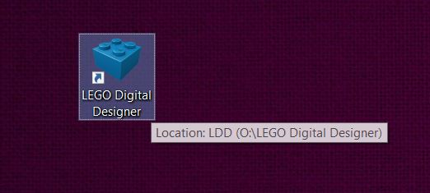

Step 2
Select “File” from the toolbar and click on “Import model (Ctrl+l)”.

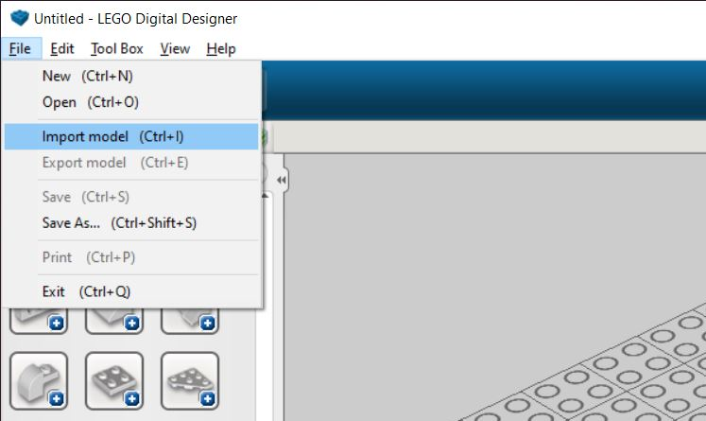

Step 3

Navigate to the directory containing the model, and change the file extension from *.lxf to *.ldr in the bottom right corner of the screen.

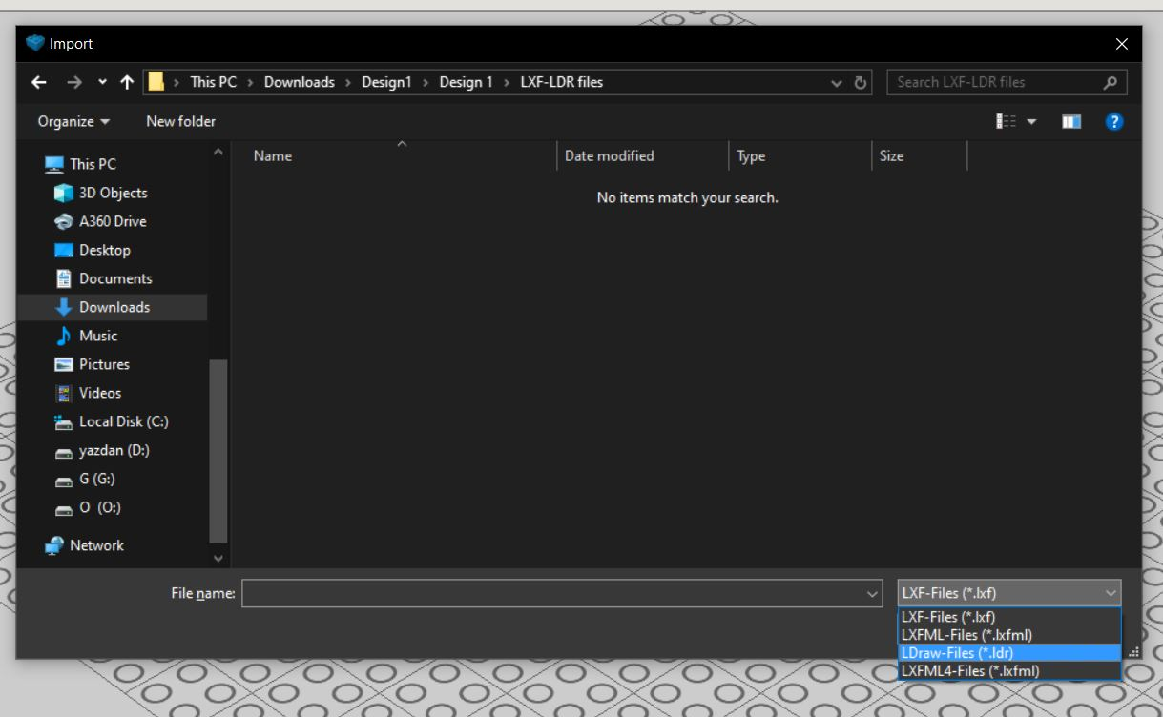

Step 4
Select the model (of type LDR) and click on “Open”.



